IT-015: IT Security Tracker Maintenance

Prepared by: Erik Demchuk
Reviewed by: _______________________________
QA Approval: _______________________________
Effective Date: March 16, 2026

Department: | Information Technology
SOP ID: | IT-015
Version: | 1.8
Resources: | Security & System Connection Tracker spreadsheet  Security Tracker Apps Script  Systems Health Monitor spreadsheet
Quick Guide: | - Start in Access Control when a new request comes in.  - Use Review Checks to work reviews and set future follow-up dates.  - Use Incidents when something is broken or access is blocked.

1. Purpose
To explain, in one clear workflow, how IT receives requests from Slack, updates access records, schedules reviews, and logs incidents in the Security & System Connection Tracker.

2. Scope
This SOP applies to anyone in IT who works in the Security & System Connection Tracker.
It covers the three working tabs: Access Control, Review Checks, and Incidents.

3. Responsibilities
Role | Responsibility
IT Administrator | Monitors Slack intake, reviews access requests, maintains the account register, and triages incidents.
IT Owner | Creates, changes, or removes access in the target system and records the real account identifier in the tracker.
Manager / System Owner | Approves or denies business access where required and supports review decisions for unusual or privileged access.
IT Manager | Owns escalations, approves workflow changes, and ensures the tracker remains operational.
QA Manager | Approves SOP revisions and confirms the process remains aligned with compliance expectations.

4. Definitions
Term | Definition
Access Control | The tab where you approve requests, confirm active access, and view archived request history.
Review Checks | The tab where you work review items and schedule follow-up dates.
Incidents | The tab where you track system issues and access problems.
Access Status | Shows whether the account exists in the target system.
Next Check Date | Future date used when the review should be looked at later instead of now.
System Security menu | Menu used to sync requests, generate review checks, and run maintenance.

5. Procedure
5.1 Start Here
When you open the workbook for the first time, use this simple rule:
- Access Control = work new requests and check active access.
- Review Checks = work review items and set follow-up dates.
- Incidents = log and track system issues.

5.2 Receive and Review a New Access Request
New access requests are normally submitted from Slack through the System Access modal. The request is logged into ACCESS REQUESTS.
- Open the Access Control tab.
- Find the new row in ACCESS REQUESTS.
- Check Target User, Company Email, Dept, System, Access Level, Reason, Manager, and System Impact.
- Enter the IT Owner who will handle the setup if the request is approved.
- If the request is unclear or unusual, stop and confirm it before approving.
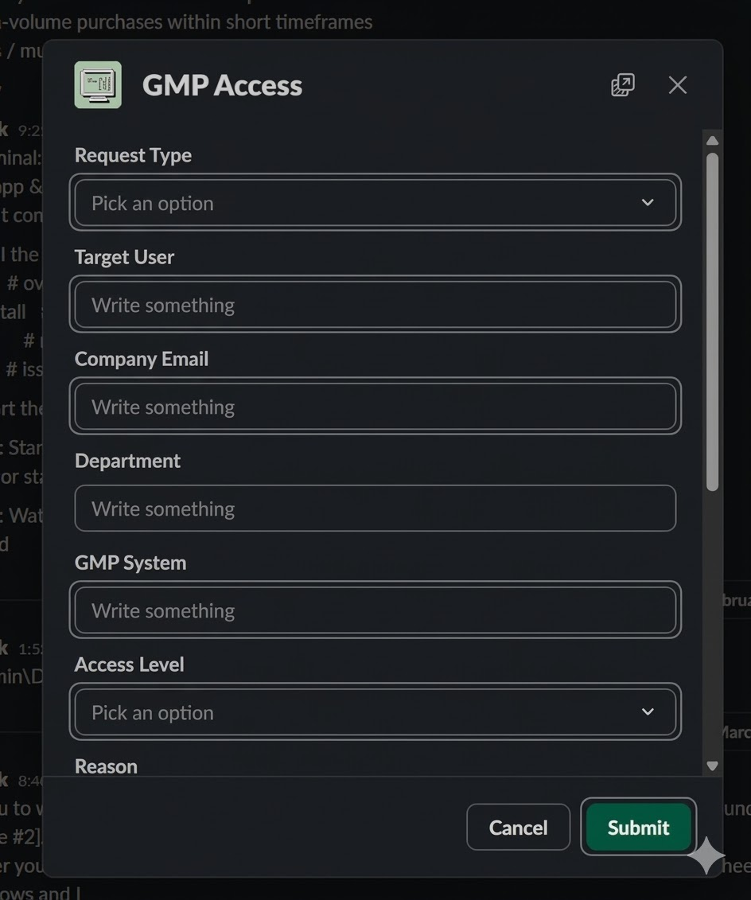
Figure 1. Slack System Access modal used to submit a new access request.

5.3 Approve or Deny the Request
The Approval column controls whether the request moves forward.
- Set Approval to Approved or Denied.
- If denied, add a short reason if needed and stop.
- If approved, continue to access setup.

5.4 Complete Access Setup and Sync the Account
Approved requests are moved into ACTIVE SYSTEM ACCOUNTS through the sync step.
- Create or update the account in the target system.
- Record the real account identifier in Access ID. Never store passwords in the tracker.
- Use Access Setup Status to track the work: Open, In Progress, Completed, Removing Access, or Closed.
- Run System Security -> Sync Approved Requests.
- Confirm the request leaves ACCESS REQUESTS.
- Confirm the account appears in ACTIVE SYSTEM ACCOUNTS under the correct system category.
- Confirm the processed request is retained in ARCHIVED REQUESTS.
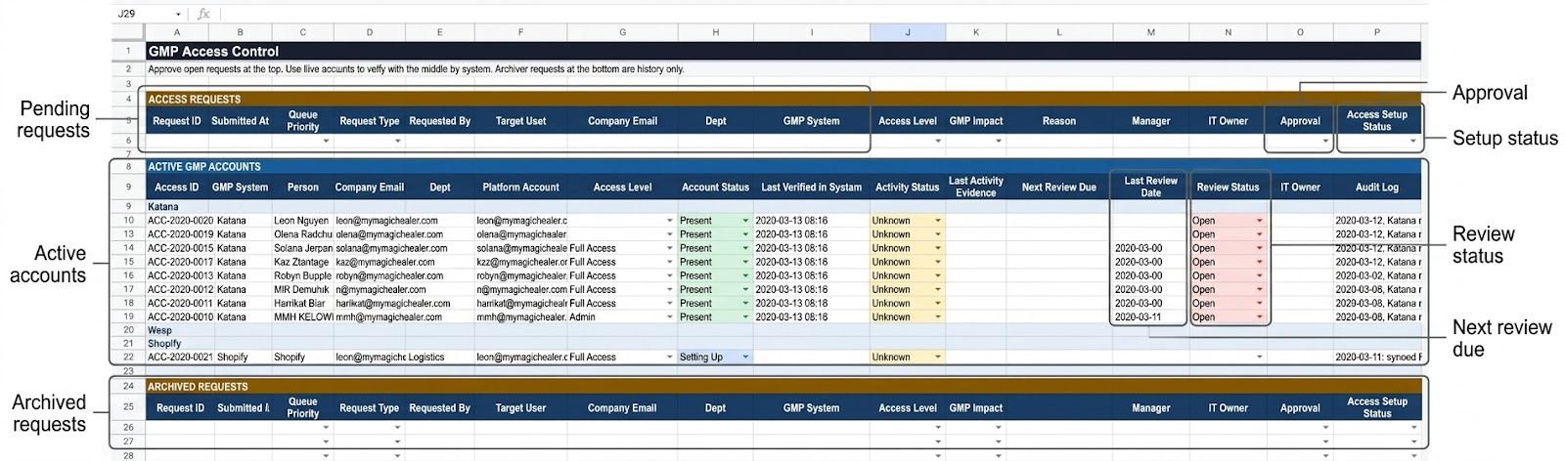
Figure 2. Access Control tab showing pending requests, active accounts, and archived requests.

5.5 Work Review Checks
Use Review Checks when the tracker tells you an account needs attention.
- Open Review Checks.
- Read Check Needed, Person, System, Access Level, and Access Status.
- Choose Reviewer Action: Keep, Reduce, Remove, or Need Info.
- If the review should happen later, set a future Next Check Date.
- If the review is finished, set Review Status to Done.

5.6 Schedule a Future Review Date
Use Next Check Date when the review should be revisited later instead of worked now.
- Use the orange top cell to set one follow-up date for all open review rows.
- Use a row-level Next Check Date if one account needs a different date.
- A future date keeps the review under SCHEDULED FOLLOW-UPS until the date is due.
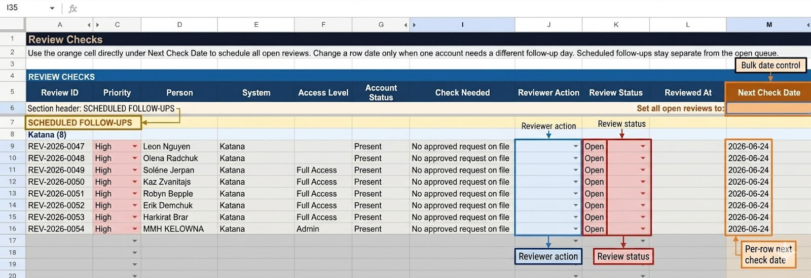
Figure 3. Review Checks tab showing the bulk date control, review action, review status, and per-row next check date.

5.7 Log and Work an Incident
Use Incidents when something is broken, blocked, or not working correctly.
- Log the issue through /it-alert or /system-issue, or add it manually if Slack is unavailable.
- Complete Severity, System, Reported By, Summary, Assigned To, and Status.
- Update the same row as the issue moves from Open to Investigating to Resolved.
- Link the related Access ID or Request ID when the issue is tied to access.
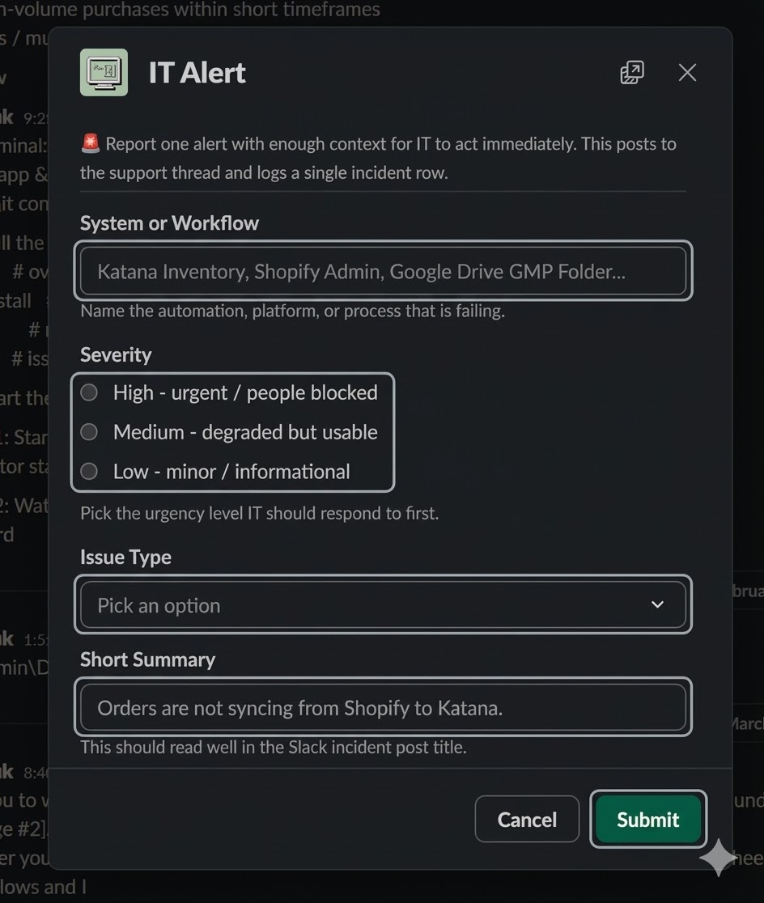
Figure 4. Slack IT Alert modal used to submit a new incident.

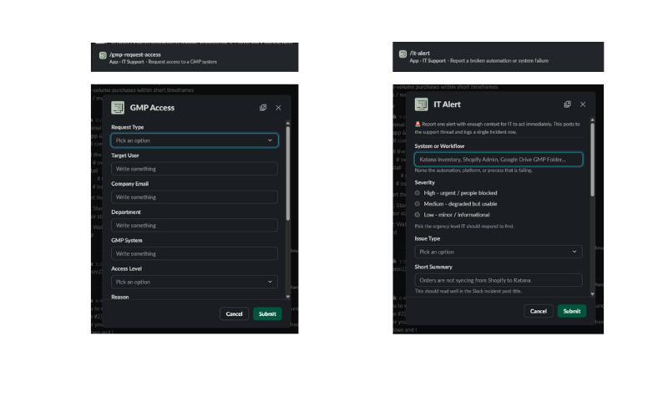
Figure 5. Incidents tab showing the logged incident row and current status fields.

5.8 Run Routine Maintenance
Use the System Security menu to refresh data and rebuild the review queue when needed.
Menu Action | Purpose
Refresh Katana Accounts | Pull Katana account presence data and update account rows.
Refresh Activity Signals | Recalculate generic activity bands and review indicators from current evidence.
Refresh Shopify Activity | Update Shopify-specific activity evidence and then refresh broader activity signals.
Generate Review Checks | Create or update review rows based on active-account risk and staleness.
Run Daily Maintenance | Run the normal daily sequence for account refresh and review generation.

- If something stops working, first run the relevant refresh action or Generate Review Checks.
- Use Setup Triggers only when automation triggers are missing or broken.

6. References
Security & System Connection Tracker spreadsheet
Security Tracker Apps Script
Systems Health Monitor spreadsheet
IT-008 - IT Security & Access Control
IT-010 - Cyber Security Incident Response
FDA 21 CFR Part 11 - Electronic Records; Electronic Signatures

7. Attachments
Attachment | Summary
Attachment A | Slack System Access request modal screenshot.
Attachment B | Access Control workbook screenshot.
Attachment C | Review Checks workbook screenshot.
Attachment D | Slack IT Alert modal screenshot.
Attachment E | Incidents workbook screenshot.

The screenshots listed above are used in Section 5 to illustrate the live workflow. Keep the approved image files with the SOP asset set so the screenshots can be updated without changing the document structure.

8. Revision History
Version | Effective Date | Description of Change | Change Control #
1.8 | March 16, 2026 | Simplified the summary block and restructured the procedure into a first-time-user workflow with clearer step order. | Pending
1.7 | March 16, 2026 | Reduced embedded screenshot size and kept screenshots in the procedure only, while leaving Attachments as the screenshot inventory list. | Pending
1.6 | March 16, 2026 | Updated terminology to the live tracker, added smoother operational process text, and embedded current screenshots for Slack intake, Access Control, Review Checks, and Incidents. | Pending
1.5 | March 11, 2026 | Rewrote the local Word version, corrected links, and aligned the content to the live 3-tab tracker, slash commands, categories, and current trigger set. | Pending
1.4 | March 6, 2026 | Removed Google Apps Script function detail and tightened the procedure flow for operations use. | Pending
1.3 | March 6, 2026 | Added embedded tracker screenshots to the formatted SOP attachments. | Pending
1.2 | March 6, 2026 | Reformatted the SOP to the corporate template and aligned the document to the 3-tab workbook model. | Pending
1.0 | January 30, 2026 | Initial release based on the earlier tracker layout. | n/a

